User Guide

Maintaining research plot data in LIO
Land Information Ontario Data Class
  - Natural Resources Information Unit
  - Science and Research Branch
  - Provincial Services Division
  - Ministry of Natural Resources and Forestry
2020-11-20

Disclaimer
This technical documentation has been prepared by Her Majesty the Queen in right of Ontario as represented by the Ministry of Natural Resources and Forestry (the “Ministry”). No warranties or representations, express or implied, statutory or otherwise shall apply or are being made by the Ministry with respect to the documentation, its accuracy or its completeness. In no event will the Ministry be liable or responsible for any lost profits, loss of revenue or earnings, claims by third parties or for any economic, indirect, special, incidental, consequential or exemplary damage resulting from any errors, inaccuracies or omissions in this documentation; and in no event will the Ministry’s liability for any such errors, inaccuracies or omissions on any particular claim, proceeding or action, exceed the actual consideration paid by the claimant involved to the Ministry for the materials to which this instructional documentation relates. Save and except for the liability expressly provided for above, the Ministry shall have no obligation, duty or liability whatsoever in contract, tort or otherwise, including any liability or negligence. The limitations, exclusions and disclaimers expressed above shall apply irrespective of the nature of any cause of action, demand or action, including but not limited to breach of contract, negligence, strict liability, tort or any other legal theory, and shall survive any fundamental breach or breaches.
Cette publication hautement spécialisée Maintaining research plot data in LIO n'est disponible qu'en anglais conformément au Règlement 671/92, selon lequel il n’est pas obligatoire de la traduire en vertu de la Loi sur les services en français. Pour obtenir des renseignements en français, veuillez communiquer avec le ministère des Richesses naturelles et des Forêts au 705-313-3237 ou email adam.hogg@ontario.ca.
Additional Information
This document does not comply with all the guidelines for accessible digital documents. For an alternative format, email the Natural Resources Information Unit.
For more information about this document, please contact Adam Hogg in the Natural Resources Information Unit at adam.hogg@ontario.ca.

Abstract
This user guide details the specifications for the Research Plot Model spatial data classes in Land Information Ontario (LIO). Spatial data classes in the model include the parent classes: research point, research line, research polygon and research auxiliary point and the derived classes: research plot protected, research plot predisturbance notification and research plot postdisturbance notification. Frequently asked questions that provide more information about how to access/maintain the data classes are addressed in a separate document available at this link.

Note
Those with edit priviledges should edit only their own research plot data. Check-in or posting privileges will only be granted to program area administrators.
Before requesting help, please consult the Frequently Asked Questions, TipsTricks document.

Contents
Disclaimer 2
Abstract 4
Note 4
Contents 5
Acronyms 7
Layers in the Model 7
Tables that support the model 8
1. Introduction 9
2. Background and context 9
Note 11
3. Objectives 13
4. Source classes 15
4.1 Research point (RESPOINT) 15
4.2 Research line (RESLINE) 15
4.3 Research polygon (RESPOLY) 16
4.4 Research plot auxiliary point (RESAUXPNT) 16
5. Derived classes 16
5.1 Research plot protected (RESPROT) 16
5.2 Research plot predisturbance notification (RESPRED) 16
5.3 Research plot postdisturbance notification (RESPOSTD) 17
6. Links to additional information 19

Acronyms
GIS: Geographic Information System
LIO: Land Information Ontario
MNRF: Ontario Ministry of Natural Resources and Forestry
PSD: Provincial Services Division
SRB: Science and Research Branch
NRIU: Natural Resources Information Unit
NRIS: Natural Resources Information Section
FMP: Forest management planning
SFL: Sustainable Forest License
OGF: Ontario geospatial feature
NDD: Non-standard data delivery
GDDS: Geospatial Data Delivery Service

Layers in the Model
Research Point (RESPOINT)
Research Line (RESLINE)
Research Polygon (RESPOLY)
Research Plot Auxiliary Point (RESAUXPT)
Research Plot Protected (RESPROT)
Research Plot Predisturbance Notification (RESPRED)
Research Plot Postdisturbance Notification (RESPOSTD)

Tables that support the model
Research Protection
Research Contact
Research Study
Research Point Note
Research Point Activity
Research Line Note
Research Line Activity
Research Poly Note
Research Poly Activity

- Introduction
This guide is intended for Ontario Ministry of Natural Resources and Forestry staff with responsibility for maintaining research plot data via the Land Information Ontario (LIO) editor application and data warehouse database. It provides background information and best practices that can be used to perform common activities required for regular maintenance of research/monitoring plot data.
This document also contains guidance for use of research plot data in LIO. It includes definitions of research plot data layers, instructions on how to enter values using the LIO editor, and a description of how the data model works. The focus is on desktop management and revision of plot location data.
The research plot layers contain spatial plot features from several MNRF research and monitoring programs. For example, growth and yield, barbed wire hair trap, and multiple species inventory monitoring plots are included as are research/monitoring program names, leads, and contact information. For program specific information, request the desired information directly from program leads, as the layers in LIO identify research plot locations but do not include the study data.
- Background and context
A Research Point, Research Line, and Research Polygon are intended to represent a feature location, line, or area where some form of natural resource management research observation, test, trial, measure, or monitoring activity has occurred or is planned. The mapped features are generally small in extent (e.g., soil water table monitor, tree cavity nest), and can be used to represent the locations of sampling techniques (e.g., basal area prism sweep). The standard LIO data life cycle is shown in Figure 1. Data is edited in spring and summer and posted to the forest information (FI) portal to support forest management planning during fall and winter.
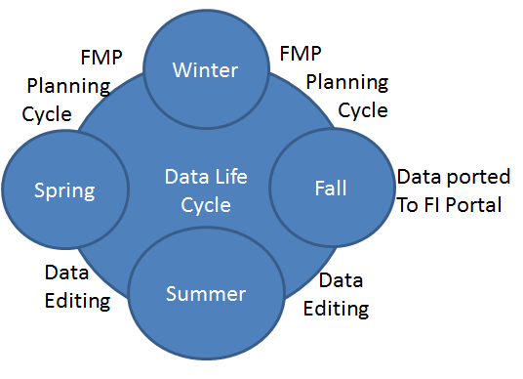
Figure 1. The annual LIO data life cycle that supports forest management planning (FMP) distributed throught the Forest Information Portal (FI Portal).
The main data classes (i.e., source layers) are Research Point (RESPOINT), Research Line (RESLINE), and Research Polygon (RESPOLY). An additional class, Research Plot Auxiliary Point (RESAUXPT), identifies point locations of features such as stakes, pins, and signs, etc., that mark or help identify the location of a research plot. Features in this layer are associated with a feature from the main data class layers. This database also includes derived layers. Derived features found in the derived layers are automatically generated based on features in the main layers. The derived layers are Research Plot Protected (RESPROT), Research Plot Predisturbance Notification (RESPRED), and Research Plot Postdisturbance Notification (RESPOSTD). These define the Area of Concern (AOC), which is an area that requires special consideration such as protection or notification of activity during the forest planning process. In these cases, follow up with the Ministry of Natural Resources and Forestry (MNRF) is required. The features in these layers are therefore buffered for each plot based on criteria defined by the program lead. The 4 source layers (LIO editor) and 3 derived layers can be accessed through:
  - LIO editor
  - LIO mapper
  - LIO data warehouse
  - Geospatial data delivery service (GDDS)
  - Annual deliveries to forest industry via the forest information (FI) portal FIPortalSupport@ontario.ca

Note
The LIO data warehouse is the authoritive source of distribution for these layers and is most up-to-date. For data currency and update schedules, contact LIO support at lio@ontario.ca.

A Research Plot Record is a set of one or many closely associated plots, combined into a single mandatory record that uniquely identifies the set and provides a common reference and a single link to related aggregated data.Research plots cover studies involving the core elements of MNRF business: forestry, aquatic, and wildlife.
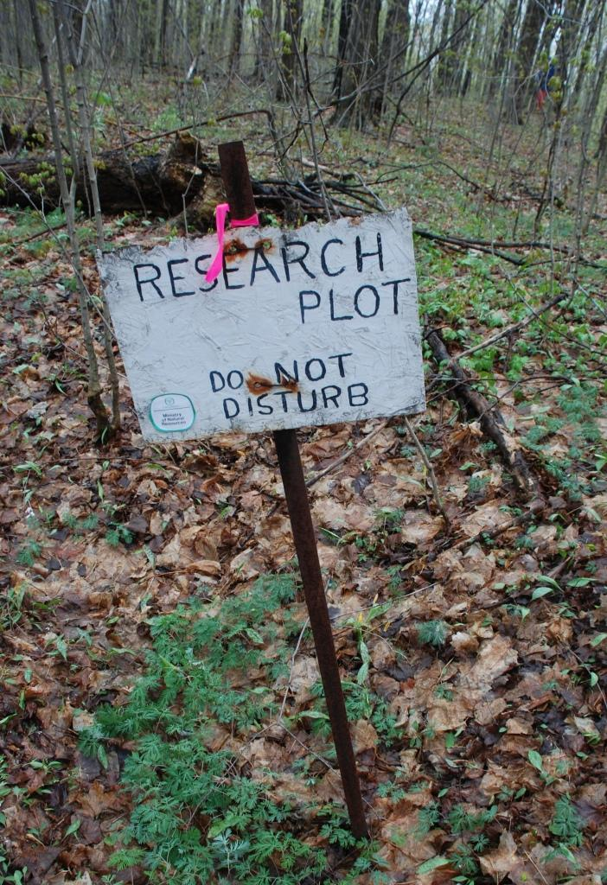
Figure 2. Example field research plot.
What is not considered a research plot?
A research plot is not the same as an Area of Natural Scientific Interest (ANSI). Research plots differ from Areas of Natural Scientific Interest. Research plots are not protected from human-caused disturbance by default and they are transient (temporally limited).

- Objectives
This guide is intended for users with a general interest in the research plot data classes:
- To provide details about how the data are structured
- To illustrate how the data structure affects its use
- To provide the necessary guidance to users entering, editing, and importing data
This document describes the information collected for each data class. A step-by-step guide for entering a feature in the parent layers for display in the derivative layers is outlined in the Frequently Asked Questions, linked as a standalone document in the metadata record. Detailed data documentation and data descriptions for each of the layers are available in their respective metadata records. Web links for each of these records are provided in Section 6.
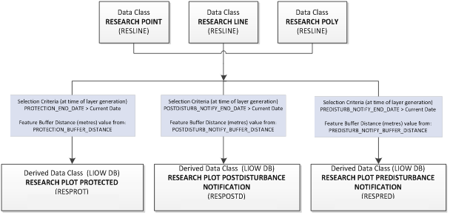
Figure 3. Research plot parent classes (top boxes) and derived class relationships.
A visual example of this is provided in figures 3 and 4. Figure 3 illustrates a scenerio where on September 1, 2016 a user added several features to the Research Point (red circles) and Research Line (yellow lines) layers. These features define locations where data collection activity occurs. When the user fills out the appropriate attribute fields, sets the Protection_End_Date validates, and posts the version to the LIO editor buffer polygons will be generated at the user defined buffer distance in the Research Plot Protected layer and will be reflected in the database the following morning, as shown in Figure 4.
Figure 4. Hypothetical research plot points and lines superimposed on an aerial photograph. (Source: Landsat 7 Sept 2005, east of Timmins, Ontario)
Figure 5. Hypothetical derived research protection polygons superimposed on an aerial photograph. (Source: Landsat 7 Sept 2005, east of Timmins, Ontario)
- Source classes
  - Research point (RESPOINT)
A research point is a feature representing a single coordinate or point-based location where some form of research observation, test, trial, measure, or monitoring activity occurred or is planned. The mapped features are generally small in extent (e.g., soil water table monitor, tree cavity nest), and can be used to represent the locations of sampling activities (e.g., basal area prism sweep).
  - Research line (RESLINE)
A research line is a feature representing a linear or transect-based location where some form of research observation, test, trial, measure, or monitoring activity occurred or is planned. Coordinates are taken along the full length of the transect. These features are generally long and narrow (width less than 10 metres).

  - Research polygon (RESPOLY)
A research polygon is a feature representing a geographic area (polygon) where some form of research observation, test, trial, measure, or monitoring activity occurred or is planned. The mapped features in this layer can be derived from existing feature geometry (e.g., a forest stand delineation in the enhanced forest resource inventory) or as generated feature geometry (e.g., 12 metre diameter circular plot around a centre post). This layer will also store research areas, which represent formalized groupings of multiple research features. Features in this layer will overlap.
  - Research plot auxiliary point (RESAUXPNT)
A research plot auxiliary point identifies the (point) location of features such as stakes, pins, and signs used to mark or locate a research plot on the ground.
- Derived classes
  - Research plot protected (RESPROT)
The research plot protected layer is derived based on research plot source features and attributes that have an active timeframe for protection within a designated area or polygon. The spatial features and attributes in this layer are sourced from the research point, research line, and research polygon data classes. The protection end date defines the active status of source features and facilitates automated lifecycle management of the features included in this derived layer. The PROTECTION_END_DATE much be after the date this layer is generated. The spatial extents of features in this derived layer are based on source feature extents to which specified buffer distances have been added. The buffer distance used to automatically generate a polygon feature in the derived protected layers is stored in the PROTECTION_BUFFER_DIST field (metres). This layer is regenerated at scheduled intervals and the previous version is archived.
  - Research plot predisturbance notification (RESPRED)
The research plot predisturbance notification is a derived layer based on research plot source features and attributes within a designated area or polygon that have an active temporal requirement for predisturbance notification. The spatial features and attributes in this layer are sourced from the research point, research line, and research polygon data classes. The PREDISTURB_NOTIFY_END_DATE must be after the date this layer was generated. The spatial extents of features in this derived layer are based on source feature extents to which specified buffer distances has been added using the applied buffer PREDISTURB_NOTIFY_BUFFER_DIST (metres) field value. This layer is regenerated at scheduled intervals and the previous version is archived.
  - Research plot postdisturbance notification (RESPOSTD)
The research plot postdisturbance notification is a derived layer based on research plot source features and attributes within a designated area or polygon that have an active temporal requirement for postdisturbance notification. The spatial features and attributes in this layer are sourced from the research point, research line, and research polygon data classes. The temporal constraint is used to assess the active status of source features and facilitates automated lifecycle management of the features included in this derived layer. The POSTDISTURB_NOTIFY_END_DATE must be after the date the layer is generated. The spatial extents of features in this derived layer are based on source feature extents to which specified buffer distances have been added (using the applied buffer: POSTDISTURB_NOTIFY_BUFFER_DIST (metres) field value). This layer is regenerated at scheduled intervals and the previous version is archived.
The editable research plot layers source (point, line, polygon) have a special relationship with the derived data layers (research plot protected, postdisturbance notification, and predisturbance notification) as illustrated in Figure 3. To create a protected area or notification feature buffered around a research plot, the plot is delineated in the source point, line, and/or polygon and after the required fields are populated a future Protection_End_Date is entered. If the current date is sooner than the Protection_End_Date, a protected or notification polygon feature will be generated at the desired buffer distance and added to the desired protection or notification layer. When the current date passes the Protection_End_Date, the protection and/or notification polygons are automatically removed.

- Links to additional information
Official LIO metadata record for:
- Research point (RESPOINT)
https://www.javacoeapp.lrc.gov.on.ca/geonetwork/srv/en/main.home?uuid=334a4d50-5769-4640-be57-ad5b31c270de

- Research line (RESLINE)
https://www.javacoeapp.lrc.gov.on.ca/geonetwork/srv/en/main.home?uuid=19f54552-6cd5-4633-811e-4b6dabd476ea

- Research polygon (RESPOLY)
https://www.javacoeapp.lrc.gov.on.ca/geonetwork/srv/en/main.home?uuid=880fff91-eb63-4919-8dea-5088e9644bff

- Research plot auxiliary Point (RESAUXPT)
https://www.javacoeapp.lrc.gov.on.ca/geonetwork/srv/en/main.home?uuid=fe07c803-acd1-46a1-9180-a2ff0e69109e

- Research plot protected (RESPROT)
https://www.javacoeapp.lrc.gov.on.ca/geonetwork/srv/en/main.home?uuid=67bccdac-eef8-40eb-a375-95046f5e3cf6

- Research plot predisturbance notification (RESPRED)
https://www.javacoeapp.lrc.gov.on.ca/geonetwork/srv/en/main.home?uuid=4e6337f7-2d49-45bb-9058-210e62fcf47b

- Research plot postdisturbance notification (RESPOSTD)
https://www.javacoeapp.lrc.gov.on.ca/geonetwork?uuid=6e92af9b-1a42-49c9-bf3d-5f7117ecc089

