SCOOP 2013
Vertical Accuracy Assessment

  - Provincial Mapping Unit
  - Mapping and Information Resources Branch
  - Corporate Management and Information Division
  - Ministry of Natural Resources and Forestry
2020-10-23

Disclaimer
This technical documentation has been prepared by Her Majesty the Queen in right of Ontario as represented by the Ministry of Natural Resources and Forestry (the “Ministry”). No warranties or representations, express or implied, statutory or otherwise shall apply or are being made by the Ministry with respect to the documentation, its accuracy or its completeness. In no event will the Ministry be liable or responsible for any lost profits, loss of revenue or earnings, claims by third parties or for any economic, indirect, special, incidental, consequential or exemplary damage resulting from any errors, inaccuracies or omissions in this documentation; and in no event will the Ministry’s liability for any such errors, inaccuracies or omissions on any particular claim, proceeding or action, exceed the actual consideration paid by the claimant involved to the Ministry for the materials to which this instructional documentation relates. Save and except for the liability expressly provided for above, the Ministry shall have no obligation, duty or liability whatsoever in contract, tort or otherwise, including any liability or negligence. The limitations, exclusions and disclaimers expressed above shall apply irrespective of the nature of any cause of action, demand or action, including but not limited to breach of contract, negligence, strict liability, tort or any other legal theory, and shall survive any fundamental breach or breaches.
Cette publication spécialisée n’est disponible qu’en anglais.

Additional Information
This document does not comply with all the applicable guidelines for accessible digital documents. For an alternative format please email Provincial Mapping Unit at pmu@ontario.ca.
For more information about this document, please contact Provincial Mapping Unit at pmu@ontario.ca.

Executive Summary

Key Words
South Central Ontario Orthophotography Project 2013, Vertical Accuracy, Raster, Digital Surface Model, Digital Terrain Model, Land Information Ontario, Ministry of Natural Resources and Forestry, Mapping and Information Resources Branch, Provincial Mapping Unit

Abstract
This report details a vertical accuracy assessment of the elevation products derived from the South Central Ontario Orthophotography Project (SCOOP) 2013, completed in 2015 for a study location in Cobourg, Ontario. This accuracy assessment creates general accuracy metrics for similar elevation products based on the guidelines of ASPRS Positional Accuracy Standards for Digital Geospatial Data and discusses the suitability and limitations of the elevation data.

Table of Contents
Disclaimer 2
Additional Information 2
Executive Summary 3
Key Words 3
Abstract 3
Table of Contents 4
List of Figures 5
List of Tables 5
List of Acronyms 5
List of Definitions 7
95th percentile 7
Check Point (checkpoint) 7
Confidence Level 7
Control Point (ground control point) 7
Digital Elevation Model (DEM) 7
Digital Terrain Model (DTM) 8
Digital Surface Model (DSM) 8
Mass Points 9
Minimum and Maximum 9
Relative Vertical Accuracy 9
Root Mean Square Error (RMSE) 10
Standard Deviation 10
1. Introduction 11
2. Assessment Procedures 12
2.1 Guidelines used in the Assessment 12
2.2 Test Site and Checkpoint Data 12
2.2.1 Test Site 12
2.2.2 Ground Control Data / Checkpoints 13
2.2.3 Land Cover Classification 13
2.2.4 Elevation Data used in Assessment 14
2.2.5 Relevant Statistics 14
2.2.6 Statistic Calculation 15
3. Results 16
3.1 Vertical Accuracy 16
3.1.1 Non-vegetated Vertical Accuracy (NVA) 16
3.1.2 Vegetated Vertical Accuracy (VVA) 17
3.1.3 Classified Vegetated Vertical Accuracy (C-VVA) 19
4. Summary 22
5. Conclusion 24
5.1 Technical Concerns 24
6. References 25

List of Figures
Figure 1: Location of test site 13
Figure 2: DTM NVA error distribution 17
Figure 3: DSM NVA error distribution 18
Figure 4: DTM VVA error distribution 19

List of Tables
Table 1: Land cover classification for NVA and VVA calculation 14
Table 2: Non-vegetated vertical accuracy (NVA) at 95% confidence level based on fast static GNSS GPS checkpoints established across the study area 17
Table 3: VVA for the DTM in reference to the GPS checkpoints collected across the study area 19
Table 4: Classified VVA (C-VVA) and NVA (C-NVA) for DTM based on different land cover classes 20

List of Acronyms
ASPRS: American Society for Photogrammetry and Remote Sensing
C-VVA: Classified Vegetated Vertical Accuracy
DEM: Digital Elevation Model
DSM: Digital Surface Model
DTM: Digital Terrain Model
GNSS: Global Navigation Satellite System
GPS: Global Positioning Systems
LIO: Land Information Ontario
MIRB: Mapping and Information Resources Branch
MNRF: Ontario Ministry of Natural Resources and Forestry
NDEP: United States National Digital Elevation Program
NVA: Non-vegetated Vertical Accuracy
OPS: Ontario Public Service
PMU: Provincial Mapping Unit
RMSE: Root Mean Square Error
SCOOP: South Central Ontario Orthophotography Project
VVA: Vegetated Vertical Accuracy

List of Definitions

95th percentile
A statistic indicating that 95 percent of the errors in the dataset will have the absolute value of equal or lesser value and 5 percent of the errors will be of larger value. With this method, Accuracy is directly equated to the 95th percentile, where 95 percent of the errors have absolute values that are equal to or smaller than the specified amount.

Check Point (checkpoint)
A surveyed point used to estimate the positional accuracy of a geo­spatial dataset against an independent source of greater accuracy. Check points are independent from, and may never be used as, control points on the same project.
Confidence Level
The probability that errors are within a range of given values.

Control Point (ground control point)
Stationary point with accurately surveyed horizontal (x/y), vertical (z), or horizontal and vertical (x/y/z) coordinates. When used for aerotriangulation, control points are either chosen as photo-identifiable points or are “paneled” prior to flying.

Digital Elevation Model (DEM)
A generic term for digital topographic and/or bathymetric data that is comprised of x/y coordinates and z-values to represent an elevation surface.
The terms ‘DTM’ and ‘DSM’ should be used over the term ‘DEM’ to more specifically reference ‘bare-earth’ or ‘surface elevation’ model products when possible.
The term “DEM” is to be used as a broader term when referencing a generic elevation data product. The Provincial DEM is an example of a generic elevation product, given that it has been constructed using a combination of both ‘DTM’ and ‘DSM’ elevation datasets to achieve Provincial coverage.

Digital Terrain Model (DTM)
The bare earth surface (lowest surface or last reflective surface) represents the surface of the "bare-earth" terrain, after removal of vegetation and constructed features.
Photogrammetry has traditionally generated DTMs when elevations are generated by manual compilation techniques. Unless specified to the contrary, the bare-earth surface includes the top surface of water bodies, rather than the submerged surface of underwater terrain.
Similar to a DSM, a DTM can be structured either as a vector dataset (comprised of mass points and optionally 3D break lines) to model bare-earth elevations or a raster dataset that is interpolated from the vector elevation data to model bare-earth terrain elevations.
Using modern elevation point cloud classification algorithms and file formats, such as LAS, a DTM can represent a mass point dataset that has been classified for ‘bare-earth’ terrain elevations.

Digital Surface Model (DSM)
A DSM is the highest reflective surface of ground features captured by the sensor. This surface may also be referred to as the first reflective surface. The DSM may include treetops, rooftops, and tops of towers, telephone poles, and other natural or constructed features; or it may include the ground surface if there is no vegetative ground cover. Photogrammetry, IFSAR, LIDAR and sonar can all provide this type of surface, yet characteristics such as accuracy and degree of detail (ability to resolve desired surface features) may vary significantly across technologies and even within the same technology. With sonar, the DSM may include sunken vessels and other artifacts, whereas the bathymetric surface reflects the natural underwater terrain. Similarly, with photogrammetry the reflective surface may include any artifact present when the sensor mapped the area, including passing cars and trucks and similar features not normally considered to be part of a digital terrain model
Similar to a DTM, a DSM can be structured either as a vector dataset (comprised of mass points and optionally 3D break lines) to model surface elevations or a raster dataset that is interpolated from the vector elevation data to model surface elevations.
Using modern elevation point cloud classification algorithms and file formats, such as LAS, a DSM can represent a mass point dataset that has been classified for ‘surface’ elevation features.

Mass Points
Mass points are irregularly spaced points, each with x/y location coordinates and z-values, typically (but not always) used to form a TIN. When generated manually, mass points are ideally chosen to depict the most significant variations in the slope or aspect of TIN triangles. However, when generated automatically, mass point spacing and patterns depend upon the characteristics of the technologies used to acquire the data.
Minimum and Maximum
Indicate the highest and lowest error values covering the entire systematic and random error values.
Relative Vertical Accuracy
Relative vertical accuracy is a measure of the point-to-point vertical accuracy within a specific dataset. To determine relative vertical accuracy, the vertical difference between two points is measured. That difference is then compared to the difference in elevation for the same two points on the reference. The difference between the two measures represents the relative accuracy. The reference must have at least three times the accuracy of the intended product accuracy, ensuring that all systematic errors and blunders have been removed. Relative vertical accuracy, an important characteristic of elevation data used for calculating slope, should be documented in the DEM metadata file.
Root Mean Square Error (RMSE)
RMSE is a statistic representing the square root of the mean of squared errors for a sample. The RMSE includes both random and systematic error. If there is no systematic error component (i.e. the RMSE is measured from a normal error distribution with no or minimum bias) then the RMSE is the statistical equivalent of the standard deviation.
Standard Deviation
A statistic indicating how spread-out the elevation vertical errors are around the (arithmetic) mean. It can be used as a measure of the elevation data precision.

1. Introduction
This accuracy assessment was conducted on 2 metre resolution raster elevation derivatives, the digital terrain model and digital surface model, using high accuracy field GPS ground check points.
This assessment included the following tasks:
- Calculating the Non-vegetated Vertical Accuracy (NVA) of the two different elevation products and Vegetated Vertical Accuracy (VVA) accuracy statistics of the DTM;
- Calculating the Classified Non-vegetated Vertical Accuracy (C-NVA) of the two elevation products and Classified Vegetated Vertical Accuracy (C-VVA) accuracy statistics of the DTM;
- Comparing the different technologies of the data acquisition;
- Evaluating the GPS check points and associated land cover classes;
- Applying ASPRS elevation vertical accuracy assessment method and discussing the limitations.
The document is divided into three main sections:
- Elevation vertical accuracy assessment procedures;
- Assessment results, including NVA, VVA, C-NVA, and C-VVA;
- Summary and technical concerns.

2. Assessment Procedures

2.1 Guidelines used in the Assessment
The vertical accuracy assessment is based on the American Society for Photogrammetry and Remote Sensing (ASPRS) Positional Accuracy Standards for Digital Geospatial Data (ASPRS, 2015). According to the guidelines, if the data set errors are normally distributed and any significant systematic errors and biases have been removed, the NVA was calculated as 1.96xRMSE, and VVA as 95th percentile. The standards also recommend that the mean error be less than 25% of the specified Root Mean Square Error (RMSE) value for the project.

2.2 Test Site and Checkpoint Data

2.2.1 Test Site
Test sites were located in the Cobourg area just south of Peterborough (see Figure 1).
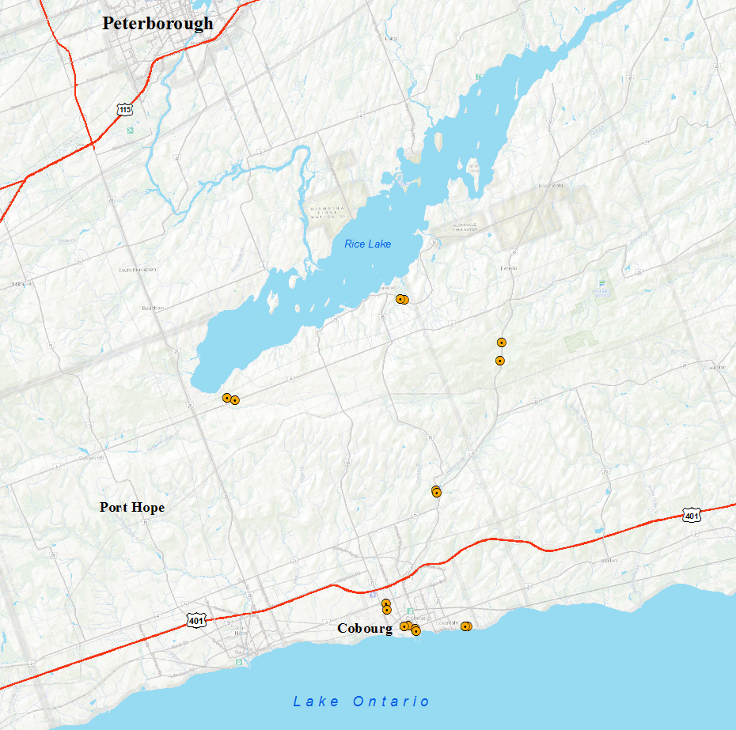
Figure 1: Location of test site

2.2.2 Ground Control Data / Checkpoints
Altogether, 937 checkpoints were collected at 26 profile lines.
The major steps used to establish checkpoints for the accuracy assessment procedure were followed in accordance with the United States National Digital Elevation Program (NDEP) guidelines (NDEP, 2004).
The data used in this accuracy assessment is available for download on Land Information Ontario (LIO) in both the Ontario Digital Surface Model (Imagery-Derived) and Ontario Digital Elevation Model (Imagery-Derived) metadata records.

2.2.3 Land Cover Classification
The checkpoints were collected within the following land cover classes: Conifer, Deciduous, Grass, Grass/Treed Mix, Hydro Lines, Mixed Forest, Open Area, Plantation, Road, and Urban/Built-up.
Table 1 shows the guidelines of land cover classification used in calculation of NVA and VVA.
Table 1: Land cover classification for NVA and VVA calculation
Surface Type | NVA/VVA Class | Land cover Class | Description
Open / Hard surface | NVA | Urban Terrain | Concrete or asphalt surfaces located in an urban or residential setting
Open / Hard surface | NVA | Road | Open gravel or asphalt road surface; points captured down the road centreline
Open / Soft surface | NVA | Short Grass | Short grass <= 15 cm in height, managed by regular cutting, such as lawns, municipal parks
Open / Soft surface | VVA | Long Grass | Grass >= 15 cm which may include hay, golden rod or tall non-woody plants. May include hay pasture or fallow fields that are regenerating
Open / Soft surface | VVA | Hydro Lines | Hydro or power corridor, represented by long grass, with some woody plants and shrub cover
Closed / Vegetated / Soft surface | VVA | Grass / Treed Mix | A combination of regenerating vegetation and shrub/thicket vegetation [experimental class]
Closed / Vegetated / Soft surface | VVA | Deciduous Forest | Tree cover > 60% with deciduous tree species > 75% of canopy cover
Closed / Vegetated / Soft surface | VVA | Plantation Forest | Conifer tree cover > 60% with trees planted in a uniform manner (artificial or cultural or anthropogenic-based disturbances)
Closed / Vegetated / Soft surface | VVA | Mixed Forest | Tree cover > 60% with conifer tree species > 25% and deciduous tree species > 25% of canopy cover
Closed / Vegetated / Soft surface | VVA | Conifer Forest | Tree cover > 60% with conifer tree species > 75% of canopy cover

2.2.4 Elevation Data used in Assessment
The elevation datasets used in the project are from the SCOOP 2013 project in the Ontario Digital Surface Model (Imagery-Derived) and Ontario Digital Elevation Model (Imagery-Derived). The DSM was interpolated from the Ontario Classified Point Cloud (Imagery-Derived). The DTM was interpolated from the ground class in the point cloud.

2.2.5 Relevant Statistics
For the purposes of this assessment, the following statistics were selected as the most relevant error statistics that can be used in combination to obtain a more complete understanding of the error characteristics:
- Sample size
- Skew
- Minimum error
- Maximum error
- Mean error
- Median error
- Sample standard deviation
- Root Mean Square Error (RMSE)
- 95th percentile accuracy
- 95% confidence level accuracy

2.2.6 Statistic Calculation
Elevation differences were calculated between respective elevation datasets and the control data:
- For bare earth accuracy evaluation in open area, elevation was extracted terrain model at Global Positioning Systems (GPS) ground checkpoints for comparison with GPS data;
- Elevation extraction from the above steps were carried out using the cell value;
- For comparison, the elevation difference was calculated by subtracting checkpoint elevation value from the elevation to be evaluated. For example, (DTM – GPS checkpoint) was used as elevation difference between DTM and GPS ground checkpoint.

3. Results

3.1 Vertical Accuracy

3.1.1 Non-vegetated Vertical Accuracy (NVA)
In accordance with the ASPRS guidelines, vertical elevation accuracy is estimated using the RMSE method and reported in ground distances at a 95% confidence level. The accuracies and major error statistics of the elevation datasets for bare earth area are shown in Table 2.
Table 2: Non-vegetated vertical accuracy (NVA) at 95% confidence level based on fast static GNSS GPS checkpoints established across the study area
NVA | DTM | DSM
Sample Number | 499 | 499
Skewness | -2.051 | 6.094
Min (m) | -1.676 | -0.440
Max (m) | 0.808 | 3.425
Mean (m) | -0.049 | 0.002
Median (m) | -0.055 | -0.053
SD (m) | 0.179 | 0.285
RMSE (m) | 0.186 | 0.285
95% Accuracy (m) | -0.364 | 0.558
The following graphs (Figures 2 and 3) show error distribution in open areas for each product:
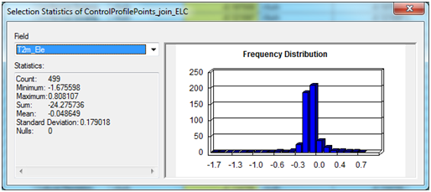
Figure 2: DTM NVA error distribution
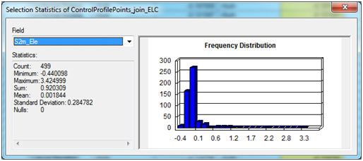
Figure 3: DSM NVA error distribution
The Non-vegetated Vertical Accuracy (NVA) is defined as the accuracy of the elevation data in open terrain condition only. It is reported with respect to the 95% confidence level as follows:
- “DTM data set was tested to meet ASPRS Positional Accuracy Standards for Digital Geospatial Data (2014) for a ____ (meter) RMSE_{z} Vertical Accuracy Class (Note: need to be decided by data users). Actual NVA accuracy was found to be RMSE_{z} = 0.186 meters, equating to +/- 0.364 meters at 95% confidence level.”
- “DSM data set was tested to meet ASPRS Positional Accuracy Standards for Digital Geospatial Data (2014) for a ____ (meter) RMSE_{z} Vertical Accuracy Class (Note: need to be decided by data users). Actual NVA accuracy was found to be RMSE_{z} = 0.285 meters, equating to +/- 0.558 meters at 95% confidence level.”

3.1.2 Vegetated Vertical Accuracy (VVA)
The error statistics for VVA is listed in Table 3. Note that error statistics are only provided for the DTM because a highly accurate measurement of the tree canopy would be required to do a VVA assessment of DSM and no such comparison data was available.
Table 3: VVA for the DTM in reference to the GPS checkpoints collected across the study area
VVA | DTM
Sample Number | 438
Skewness | -0.624
Min (m) | -6.257
Max (m) | 5.324
Mean (m) | -0.014
Median (m) | 0.026
SD (m) | 1.129
RMSE (m) | 1.127
95th Percentile (m) | 2.860
The following graph (Figure 4) shows the error distribution in the vegetated areas:
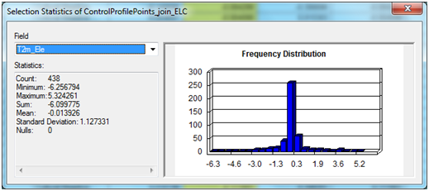
Figure 4: DTM VVA error distribution
The Vegetated Vertical Accuracy (VVA) describes the error of the data in land cover types other than open terrain. For the DTM dataset it is reported as:
- “DTM was tested to meet ASPRS Positional Accuracy Standards for Digital Geospatial Data (2015). VVA = +/- 2.860 meters at 95th percentile.”

3.1.3 Classified Vegetated Vertical Accuracy (C-VVA)
The major land cover classes in the test site include conifer, deciduous, grass, grass/treed mix, hydro lines, mixed forest, open filed, plantation, road, and urban/built-up. In this assessment, C-VVA was calculated by individual land cover classes.
Table 4 lists relevant error statistics and highlights the C-VVA at 95th percentile and C-NVA at 95% confidence level for each land cover classes.
Table 4: Classified VVA (C-VVA) and NVA (C-NVA) for DTM based on different land cover classes
DTM | Conifer | Deciduous | Grass | Grass/ Treed Mix | Hydro Lines | Mixed Forest | Open Field | Plantation | Road | Urban/ Built-up
Sample Number | 72 | 65 | 58 | 117 | 24 | 93 | 60 | 33 | 111 | 304
Skewness | 1.1 | -1.701 | -0.14 | -6.776 | -2.089 | -2.045 | 0.407 | -0.618 | -4.048 | 1.159
Min (m) | -0.612 | -3.02 | -0.328 | -6.257 | -1.676 | -5.469 | -0.183 | -2.859 | -1.478 | -0.341
Max (m) | 5.324 | 0.565 | 0.337 | 0.335 | 0.808 | 1.532 | 0.206 | 0.577 | 0.303 | 0.536
Mean (m) | 1.141 | -0.238 | 0.021 | -0.107 | 0.165 | -0.416 | -0.031 | -0.69 | -0.119 | -0.043
Median (m) | 0.583 | -0.097 | 0.027 | -0.002 | 0.273 | -0.042 | -0.033 | -0.33 | -0.082 | -0.054
SD (m) | 1.349 | 0.713 | 0.135 | 0.705 | 0.545 | 1.376 | 0.07 | 0.992 | 0.189 | 0.104
RMSE (m) | 1.76 | 0.746 | 0.136 | 0.71 | 0.559 | 1.431 | 0.076 | 1.196 | 0.222 | 0.113
95th Percentile (m) | 3.751 | 1.814 | 0.273 | 0.467 | 0.731 | 3.472 | 0.158 | 2.427 | 0.417 | 0.222
95% Accuracy (m) | 3.449 | 1.462 | 0.266 | 1.391 | 1.095 | 2.804 | 0.149 | 2.344 | 0.435 | 0.221

The Classified Vegetated (or Non-vegetated) Vertical Accuracy (C-VVA or C-NVA) describes the error of the data for each land cover classes.
For DTM it is reported as:
- “This data set was tested to meet ASPRS Positional Accuracy Standards for Digital Geospatial Data (2014). C-VVA = +/- 3.751 meters at 95th percentile in the area of conifer land cover class.”
- “This data set was tested to meet ASPRS Positional Accuracy Standards for Digital Geospatial Data (2014). C-VVA = +/- 1.814 meters at 95th percentile in the area of deciduous land cover class.”
- “This data set was tested to meet ASPRS Positional Accuracy Standards for Digital Geospatial Data (2014). C-VVA = +/- 0.273 meters at 95th percentile in the area of grass land cover class.”
- “This data set was tested to meet ASPRS Positional Accuracy Standards for Digital Geospatial Data (2014). C-VVA = +/- 0.467 meters at 95th percentile in the area of grass/treed mix land cover class.”
- “This data set was tested to meet ASPRS Positional Accuracy Standards for Digital Geospatial Data (2014). C-NVA = +/- 1.095 meters at 95% confidence level in the area of hydro lines land cover class.”
- “This data set was tested to meet ASPRS Positional Accuracy Standards for Digital Geospatial Data (2014). C-VVA = +/- 3.472 meters at 95th percentile in the area of mixed forest land cover class.”
- “This data set was tested to meet ASPRS Positional Accuracy Standards for Digital Geospatial Data (2014). C-NVA = +/- 0.149 meters at 95% confidence level in the area of open field land cover class.”
- “This data set was tested to meet ASPRS Positional Accuracy Standards for Digital Geospatial Data (2014). C-VVA = +/- 2.427 meters at 95th percentile in the area of plantation land cover class.”
- “This data set was tested to meet ASPRS Positional Accuracy Standards for Digital Geospatial Data (2014). C-NVA = +/- 0.435 meters at 95% confidence level in the area of road land cover class.”
- “This data set was tested to meet ASPRS Positional Accuracy Standards for Digital Geospatial Data (2014). C-NVA = +/- 0.221 meters at 95% confidence level in the area of urban/built-up land cover class.”
For DSM it is reported as:
- “This data set was tested to meet ASPRS Positional Accuracy Standards for Digital Geospatial Data (2014). C-NVA = +/- 1.287 meters at 95% confidence level in the area of hydro lines land cover class.”
- “This data set was tested to meet ASPRS Positional Accuracy Standards for Digital Geospatial Data (2014). C-NVA = +/- 0.149 meters at 95% confidence level in the area of open field land cover class.”
- “This data set was tested to meet ASPRS Positional Accuracy Standards for Digital Geospatial Data (2014). C-NVA = +/- 0.308 meters at 95% confidence level in the area of road land cover class.”
- “This data set was tested to meet ASPRS Positional Accuracy Standards for Digital Geospatial Data (2014). C-NVA = +/- 0.584 meters at 95% confidence level in the area of urban/built-up land cover class.”

4. Summary
In this project, the Non-vegetated Vertical Accuracy (NVA) is defined as the accuracy of the elevation data in open terrain conditions only and is reported with respect to the 95% confidence level. The Vegetated Vertical Accuracy (VVA) is defined as the accuracy of elevation under canopy.
The following results were calculated for this study:
“DTM data set was tested to meet ASPRS Positional Accuracy Standards for Digital Geospatial Data (2014) for a ____ (meter) RMSE_{z} Vertical Accuracy Class (Note: need to be decided by data users). Actual NVA accuracy was found to be RMSE_{z} = 0.186 meters, equating to +/- 0.364 meters at 95% confidence level. Actual VVA accuracy was found to be +/- 2.860 meters at 95th percentile.”
“DSM data set was tested to meet ASPRS Positional Accuracy Standards for Digital Geospatial Data (2014) for a ____ (meter) RMSE_{z} Vertical Accuracy Class (Note: need to be decided by data users). Actual NVA accuracy was found to be RMSE_{z} = 0.285 meters, equating to +/- 0.558 meters at 95% confidence level.
The Classified Vegetated Vertical Accuracy (C-VVA) for each product describes the accuracy of the data at 95th percentile for each land cover class, while the Classified Non-vegetated Vertical Accuracy (C-NVA) for each product describes the accuracy of the data at 95% confidence level for each land cover class:
For DSM elevation product:
“C-NVA = +/- 1.287 meters at 95% confidence level in the area of Hydro Lines.”
“C-NVA = +/- 0.149 meters at 95% confidence level in the area of Open Field.”
“C-NVA = +/- 0.308 meters at 95% confidence level in the area of Road.”
“C-NVA = +/- 0.584 meters at 95% confidence level in the area of Urban/Built-up.”

For DTM elevation product:
“C-VVA = +/- 3.751 meters at 95th percentile in the area of Conifer land cover class.”
“C-VVA = +/- 1.814 meters at 95th percentile in the area of Deciduous land cover class.”
“C-VVA = +/- 0.273 meters at 95th percentile in the area of Grass land cover class.”
“C-VVA = +/- 0.467 meters at 95th percentile in the area of Grass/Treed Mix.”
“C-VVA = +/- 3.472 meters at 95th percentile in the area of Mixed Forest.”
“C-VVA = +/- 2.427 meters at 95th percentile in the area of Plantation.”
“C-NVA = +/- 1.095 meters at 95% confidence level in the area of Hydro Lines.”
“C-NVA = +/- 0.149 meters at 95% confidence level in the area of Open Field.”
“C-NVA = +/- 0.435 meters at 95% confidence level in the area of Road.”
“C-NVA = +/- 0.221 meters at 95% confidence level in the area of Urban/Built-up.”

5. Conclusion

5.1 Technical Concerns
The ASPRS methods used here assume that the data set errors are normally distributed and that any significant systematic errors or biases have been removed. As a general rule, the mean error should be less than 25% of the specified RMSE value for the project (ASPRS, 2015). In this project, the mean errors are greater than 25% of the specified RMSE value. Further investigation into GPS survey and the elevation data needs be done to solve this issue.

6. References
ASPRS, 2015, ASPRS Positional Accuracy Standards for Digital Geospatial Data, Photogrammetric Engineering & Remote Sensing, Vol. 81, No. 3, March 2015, pp. A1- A26.
Maune, D.F., 2007. Digital Elevation Model Technologies and Applications: The DEM Users Manual, 2nd Edition, the American Society for Photogrammetry and Remote Sensing
National Digital Elevation Program (NDEP). 2004. Guidelines for Digital Elevation Data, Version 1.0, United States of America.

Version 1617.1

