SWOOP 2010
Mass Points and Breaklines
User Guide
  - Provincial Mapping Unit
  - Mapping and Information Resources Branch
  - Corporate Management and Information Division
  - Ministry of Natural Resources and Forestry
2020-03-18

Disclaimer
This technical documentation has been prepared by Her Majesty the Queen in right of Ontario as represented by the Ministry of Natural Resources and Forestry (the “Ministry”). No warranties or representations, express or implied, statutory or otherwise shall apply or are being made by the Ministry with respect to the documentation, its accuracy or its completeness. In no event will the Ministry be liable or responsible for any lost profits, loss of revenue or earnings, claims by third parties or for any economic, indirect, special, incidental, consequential or exemplary damage resulting from any errors, inaccuracies or omissions in this documentation; and in no event will the Ministry’s liability for any such errors, inaccuracies or omissions on any particular claim, proceeding or action, exceed the actual consideration paid by the claimant involved to the Ministry for the materials to which this instructional documentation relates. Save and except for the liability expressly provided for above, the Ministry shall have no obligation, duty or liability whatsoever in contract, tort or otherwise, including any liability or negligence. The limitations, exclusions and disclaimers expressed above shall apply irrespective of the nature of any cause of action, demand or action, including but not limited to breach of contract, negligence, strict liability, tort or any other legal theory, and shall survive any fundamental breach or breaches.
Cette publication spécialisée n’est disponible qu’en anglais.

Additional Information
For more information about this document, please contact the Provincial Mapping Unit at pmu@ontario.ca.

Executive Summary

Key Words
Vector, Mass Points, Breaklines, Softcopy Photogrammetry, Provincial Mapping Unit, PMU, Southwestern Ontario Orthophotography Project (SWOOP).

Abstract
SWOOP 2010 Mass Points and Breaklines elevation data is a collection of highly accurate and precise 3D mass points and breakline features that were interpreted using softcopy photogrammetry from aerial photography. This data set encompasses an area collected in the spring of 2010 covering Windsor to Tobermory and down to Niagara.

Table of Contents
Disclaimer 2
Additional Information 2
Executive Summary 3
Key Words 3
Abstract 3
Table of Contents 4
List of Figures 5
List of Acronyms 6
List of Definitions 7
Mass Points 7
Digital Elevation Model (DEM) 7
Digital Terrain Model (DTM) 7
Digital Surface Model (DSM) 8
1. Product Description 9
1.1 Geographic Extent 9
1.2 Reference System 10
2. Product Details 11
2.1 Vector Data Creation 11
2.1.1 Softcopy Photogrammetry 11
2.1.2 Z-Value Assignment of Regularly Spaced Points (20m Spaced Points) 11
2.2 Data Delivery Format 12
2.3 Use Restrictions 12

List of Figures
Figure 1: Extent of SWOOP 2010 Project Area 9
Figure 2: Example of Tile Folder 12

List of Acronyms
CGVD28: Canadian Geodetic Vertical Datum 1928
DEM: Digital Elevation Model
DTM: Digital Terrain Model
DSM: Digital Surface Model
GIS: Geographic Information Systems
LIO: Land Information Ontario
NAD83: North American Datum of 1983
PMU: Provincial Mapping Unit
SWOOP: Southwestern Ontario Orthophotography Project
TIN: Triangulated Irregular Network
UTM: Universal Transverse Mercator

List of Definitions

Mass Points
Mass points are irregularly spaced points, each with x/y location coordinates and z-values, typically (but not always) used to form a TIN. When generated manually, as is the case with the SWOOP 2010 data set, mass points are ideally chosen to depict the most significant variations in the slope or aspect of TIN triangles. However, when generated automatically, e.g., by LiDAR or IfSAR scanner, mass point spacing and patterns depend upon the characteristics of the technologies used to acquire the data.

Digital Elevation Model (DEM)
A generic term for digital topographic and/or bathymetric data that is comprised of x/y coordinates and z-values to represent an elevation surface.
The terms ‘DTM’ and ‘DSM’ should be used over the term ‘DEM’ to more specifically reference ‘bare-earth’ or ‘surface elevation’ model products when possible.
The term “DEM” is to be used as a broader term when referencing a generic elevation data product. The Provincial DEM is an example of a generic elevation product, given that it has been constructed using a combination of both ‘DTM’ and ‘DSM’ elevation datasets to achieve Provincial coverage.

Digital Terrain Model (DTM)
The bare earth surface (lowest surface, last reflective surface, or LiDAR last-return) represents the surface of the "bare-earth" terrain, after removal of vegetation and constructed features.
Photogrammetry has traditionally generated DTMs when elevations are generated by manual compilation techniques. Unless specified to the contrary, the bare-earth surface includes the top surface of water bodies, rather than the submerged surface of underwater terrain.
Similar to a DSM, a DTM can be structured either as a vector dataset (comprised of mass points and optionally 3D break lines) to model bare-earth elevations or a raster dataset that is interpolated from the vector elevation data to model bare-earth terrain elevations.
Using modern elevation point cloud classification algorithms and file formats, such as LAS, a DTM can represent a mass point dataset that has been classified for ‘bare-earth’ terrain elevations.

Digital Surface Model (DSM)
A DSM is the highest reflective surface of ground features captured by the sensor. This surface may also be referred to as the first reflective surface or LiDAR first-return. The DSM may include treetops, rooftops, and tops of towers, telephone poles, and other natural or constructed features; or it may include the ground surface if there is no vegetative ground cover. Photogrammetry, IFSAR, LIDAR and sonar can all provide this type of surface, yet characteristics such as accuracy and degree of detail (ability to resolve desired surface features) may vary significantly across technologies and even within the same technology. With sonar, the DSM may include sunken vessels and other artifacts, whereas the bathymetric surface reflects the natural underwater terrain. Similarly, with photogrammetry, LiDAR, and IFSAR the reflective surface may include any artifact present when the sensor mapped the area, including passing cars and trucks and similar features not normally considered to be part of a digital terrain model.
Similar to a DTM, a DSM can be structured either as a vector dataset (comprised of mass points and optionally 3D break lines) to model surface elevations or a raster dataset that is interpolated from the vector elevation data to model surface elevations.
Using modern elevation point cloud classification algorithms and file formats, such as LAS, a DSM can represent a mass point dataset that has been classified for ‘surface’ elevation features.

- Product Description
The primary purpose of the Southwestern Ontario Orthophotography Project (SWOOP) was to ensure the ortho-rectification of imagery appropriate enough to support 50 cm horizontal accuracy in the imagery products. The orthophotography provides high-resolution, true colour aerial coverage for Southwestern Ontario. This data serves as a valuable information resource, providing a spatial context to features existing on the landscape. Further manipulation would be required to generate derivative products such as contours and floodplain mapping.
  - Geographic Extent
The SWOOP 2010 Mass Points and Breaklines is organized into 20km x 20km tiles and includes approximately 45,000 sq km in an area covering Windsor to Tobermory and down to Niagara (see Figure 1).
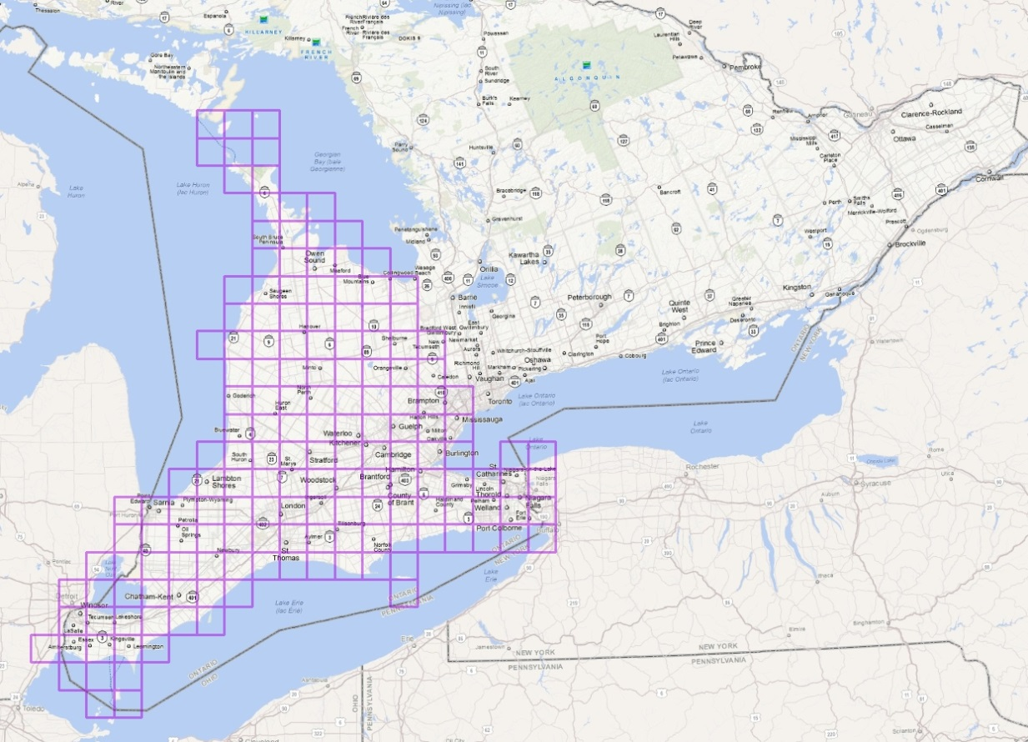
Figure 1: Extent of SWOOP 2010 Project Area
  - Reference System
Horizontal Reference System
The horizontal coordinate system of the mass points and breaklines is Universal Transverse Mercator (UTM). The horizontal datum is the North American Datum of 1983 (NAD83).
Vertical Reference System
The vertical coordinate system of the mass points and breaklines is based on the Canadian Geodetic Vertical Datum 1928 (CGVD28) of the Geodetic Survey Division of Natural Resources Canada and is measured in metres above mean sea level. For more information please see the Height Reference System Modernization (https://www.nrcan.gc.ca/height-reference-system-modernization/9054#_Canadian_Geodetic_Vertical_1).
- Product Details
  - Vector Data Creation
    - Softcopy Photogrammetry
Bare earth elevation measurements are always the ultimate goal of any elevation modeling for hydrologic purposes. The presence of vegetation poses the greatest problem in obtaining this information. Elevation data was collected using soft-copy photogrammetry. This method differs from typical analog photogrammetry methods as it incorporates analytical stereo plotter functionality and integrates numerous photogrammetric tasks into one digital (computer) environment. Using photo stereo pairs, the computer software automatically calculates a stereo model and from that, a digital terrain model. Using digital stereo glasses in order to see in three dimensions, an analyst can create points and breakline features in x, y and z coordinate space (3 dimensions). In order to capture an elevation measurement, the analyst moves the cursor up or down until they are certain that the cursor is located on the bare surface of the model.
    - Z-Value Assignment of Regularly Spaced Points (20m Spaced Points)
Z values for this data set were assigned using widely used and accepted soft copy photogrammetric methods. All x/y locations for this data set were generated automatically. Assignment of bare earth z values was then completed, in most cases using automated processes in combination with interactive/manual editing by GIS technicians using the soft copy photogrammetric methods.

  - Data Delivery Format
The SWOOP 2010 Mass Points and Breaklines data is currently distributed through by Land Information Ontario (LIO) through the Ontario GeoHub as part of the Ontario Mass Points and Breaklines (https://geohub.lio.gov.on.ca/search?q=ontario%20mass%20points%20and%20breaklines).
The downloaded package will contain a Tile Index shape file and a folder containing 163 zipped tiles. Each zipped tile contains of two shape files:
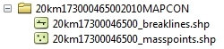
Figure 2: Example of Tile Folder

  - Use Restrictions
The SWOOP 2010 Mass Points and Breaklines is considered Open Data. You are free to copy, modify, publish, translate, adapt, distribute or otherwise use the Information in any medium, mode or format for any lawful purpose. If you do any of the above you must use the following attribution statement “Contains information licensed under the Open Government Licence – Ontario.” See Open Government Licence (https://www.ontario.ca/page/open-government-licence-ontario).
Version 1516.1

