User Guide
for
Spot Height
LIO Data Class
  - Provincial Mapping Unit
  - Mapping and Information Resources Branch
  - Corporate Management and Information Division
  - Ministry of Natural Resources and Forestry
2020-03-03

Disclaimer
This technical documentation has been prepared by Her Majesty the Queen in right of Ontario as represented by the Ministry of Natural Resources and Forestry (the “Ministry”). No warranties or representations, express or implied, statutory or otherwise shall apply or are being made by the Ministry with respect to the documentation, its accuracy or its completeness. In no event will the Ministry be liable or responsible for any lost profits, loss of revenue or earnings, claims by third parties or for any economic, indirect, special, incidental, consequential or exemplary damage resulting from any errors, inaccuracies or omissions in this documentation; and in no event will the Ministry’s liability for any such errors, inaccuracies or omissions on any particular claim, proceeding or action, exceed the actual consideration paid by the claimant involved to the Ministry for the materials to which this instructional documentation relates. Save and except for the liability expressly provided for above, the Ministry shall have no obligation, duty or liability whatsoever in contract, tort or otherwise, including any liability or negligence. The limitations, exclusions and disclaimers expressed above shall apply irrespective of the nature of any cause of action, demand or action, including but not limited to breach of contract, negligence, strict liability, tort or any other legal theory, and shall survive any fundamental breach or breaches.
Cette publication spécialisée n’est disponible qu’en anglais.

Additional Information
This document does not comply with all the applicable guidelines for accessible digital documents. For an alternative format please email Provincial Mapping Unit at pmu@ontario.ca.
For more information about this document, please contact Provincial Mapping Unit at pmu@ontario.ca.

Executive Summary

Key Words
Spot Height, Topography, Elevation

Abstract
This user guide details the specifications for the Spot Height Land Information Ontario (LIO) Data Class.

Table of Contents
Disclaimer 2
Additional Information 2
Executive Summary 3
Key Words 3
Abstract 3
Table of Contents 4
List of Figures 5
List of Acronyms 6
1. Introduction 7
2. Objectives 8
3. Data Class: [Insert Data Class Name] 8
4. Model Diagram: [Insert Data Class Name] 9
5. Data Description 10
SPOT_HEIGHT_FT 10
6. Links to Additional Information 11
APPENDIX A: Frequently Asked Questions 12
What were the collection specifications for Spot Height? 12

List of Figures

List of Acronyms
GIS: Geographic Information System
LIO: Land Information Ontario
MNRF: Ontario Ministry of Natural Resources and Forestry
OBM: Ontario Basic Mapping
OGF: Ontario Geospatial Feature
SDI: Spatial Data Infrastructure
SPOT: Short Name for Spot Height Data Class
VCP: Vertical Control Point
- Introduction
Spot Height is a province-wide geographic database of point features identifying variations in the elevation (z value) of natural and man-made features. The point types are Spot Heights, Vertical Control Point (VCP) and Water Level / Lake Elevation. The main purpose of spot heights is for cartographic reference on a topographical map.
For more information on Spot Height contact pmu@ontario.ca.
Examples of Spot Heights:
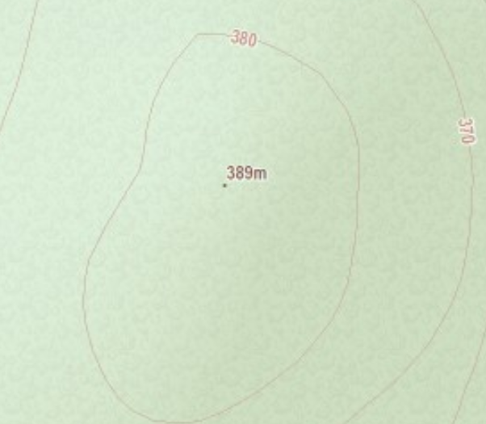
Figure 1: Spot Height at the top of a hill
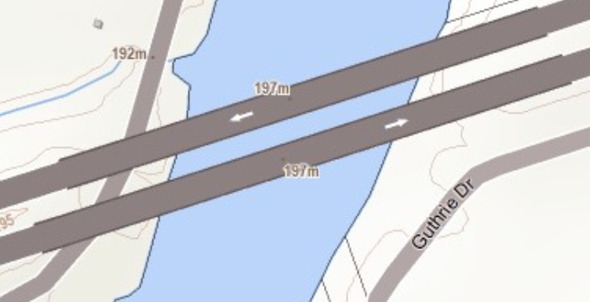
Figure 2: Spot Heights on significant features (bridges)

- Objectives
This guide is intended for users with a general interest in the Spot Height LIO Data Class. The remainder of this document describes the extent and context of the information collected the data class.
- Data Class: [Insert Data Class Name]
Point features identifying variations in the elevation (z value) of natural and man-made features. Includes:
- Spot Height: Elevation from mean sea level at a spot rounded to the nearest metre (1:20,000 scale), or to the nearest 0.5 metre (1:10,000 scale).
- Vertical Control Point Photogrammetric: A Vertical Control Point Photogrammetric is a spot elevation, typically found at a road intersection and on top of bridges, with an accuracy of 0.1 metre.
- Water Level – Lake Elevation: A Spot elevation on a named lake.
Notes:
- The submetre portion of VCP accuracy has been truncated.
- Northern elevation data was collected from OBM and other sources.
- Model Diagram: [Insert Data Class Name]
Model Effective Date: 2012-JUN-14
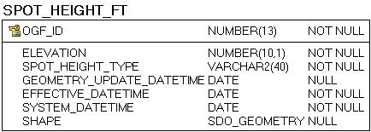
- Data Description
The main business area table(s) for this model can be found below.

SPOT_HEIGHT_FT
Identifies the elevation of a significant geographical feature. The data class contains: Spot Height, Vertical Control Point Photogrammetric, Water Level – Lake Elevation.
# | Column Name | Column Type | Mandatory | Short Name | Description
1 | OGF_ID | NUMBER(13) | Yes | OGF_ID | System generated identifier, unique at the application level.
2 | ELEVATION | NUMBER(10,1) | Yes | ELEVATION | The amount in metres that a geographic entity is above mean sea level.
3 | SPOT_HEIGHT_TYPE | VARCHAR2(40) | Yes | SPOT_TYPE | The type of spot height measurement.  VALID VALUES:  - Spot Height  - Vertical Control Point Photogrammetric  - Water Level - Lake Elevation
4 | GEOMETRY_UPDATE_DATETIME | DATE | No | GEO_UPD_DT | Date/time the geometry was created or last modified in the source database.
5 | EFFECTIVE_DATETIME | DATE | Yes | EFF_DATE | Date/time the record was created or last modified in the source database.
6 | SYSTEM_DATETIME | DATE | Yes | SYS_DATE | Date/time the record was loaded into or last modified in the LIO database.
7 | SHAPE | SDO_GEOMETRY | No | SHAPE | Geometry attribute.

- Links to Additional Information
- Access the official Metadata Record by searching Ontario GeoHub for “Spot Height”

APPENDIX A: Frequently Asked Questions

What were the collection specifications for Spot Height?
Spot Heights were collected for the Ontario Base Mapping (OBM) program. In northern Ontario additional sources also contributed data. The following information is an excerpt from “Ontario Government Specifications For the Delivery of Digital Topographic Data and Cartographic Representation Products At Medium Scales (1:10,000 and 1:20,000), Version 5”:
Spot elevations are required at the following locations with an accuracy factor of one quarter of the contour interval:
- On intersections of roads, railways, tracks, trails, transmission lines, pipe lines, aerial tramways, cut lines and other man-made linear features identifiable on the mapping photography: where a definite change occurs in the alignment of those features and, at intervals of one kilometre along these features.
- At summits, knobs, depressions, along the rim and bottom of a significant gorge, gully or rock face.
- At or near to the entrance of mine shafts.
- At or near major buildings along the run of open pit mines, quarries and gravel pits and at the lowest point of these features.
- At the foot and top of log piles, sand piles, mine dumps, embankments and On bridges, airport runways and landing strips.
- At other points that can be identified on the ground, such as prominent rock outcrops, small clearings in the bush, small islands, etc.
- Water levels on all named lakes, as well as above and below man-made dams.
Spot elevations will be shown and be accurate to:
- 1 metre at the map scale of 1:20000, and
- the nearest 0.5 metre at the map scale of 1:10000.
Water levels for lakes at 1:10000 scale mapping will be shown at the same accuracy as spot heights, to the nearest 0.5 metre in the digital file and on the hard copy, i.e. 313.0 or 313.5.
Photogrammetric vertical control points (VCPs) will be shown to the nearest 0.1 metre at both scales. The VCP is to be digitized as a point feature and the VCP elevation is attribute No. 2.
Land Information Ontario. (March, 1994). Ontario Government Specifications For the Delivery of Digital Topographic Data and Cartographic Representation Products At Medium Scales (1:10,000 and 1:20,000), Version 5. Ministry of Natural Resources. 37-38.
Version 1920.1

