
Land Information Ontario (LIO) Warehouse
Data Class Name: Wildlife Management Unit
Documentation
Produced by: Information Access and Information Management Policy Unit
Ministry of Natural Resources and Forestry
Date: July 27, 2015

Purpose

This document provides additional information to support the use of geospatial data. The Physical Model Diagram provides a visual representation of the relationships in the data class. The Data Change History lists all the modelling and access changes that have occurred during the lifecycle of the data class. A data description identifying table and field names is available upon request.

Need Assistance?
Please contact LIO Support at lio@ontario.ca or 705-755-1878 if you require help.

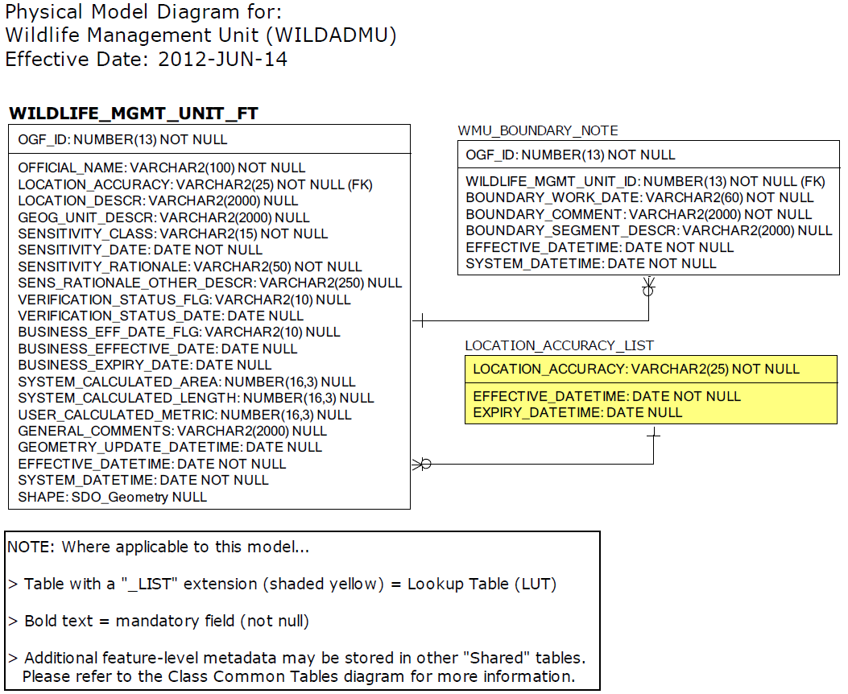

Data Class Change History

Data Class Name: Wildlife Management Unit
Data Class Short Name: WILDADMU
Date  YYYY-MM-DD | Details of Change
2013-06-03 | Access to Wildlife Management Unit has been changed from restricted to OGDE to Open Data
2008 | CLASS NAME CHANGE from "Wildlife Management Unit Legal" to "Wildlife Management Unit". This change is to address concerns from the custodian that this is not the actual legal version. The legal document is maintained and filed by the Office of the Surveyor General.  The table name has been changed from WILDLIFE_MGMT_UNIT_LEGAL to WILDLIFE_MGMT_UNIT.
2003 | NEW Data Class
Data Description
Please refer to the metadata record for the data description.

